|  |  |  |
| --- | --- | --- |
| English (HEBB)  Class: | **Writing a Europass CV** |  |
| Date: |

1. **Schools and qualifications**

The following table lists some German schools and qualifications and their American and British equivalents. Complete the table by matching the missing terms in the box below with the numbers (1-6) in the table.

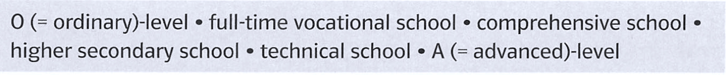

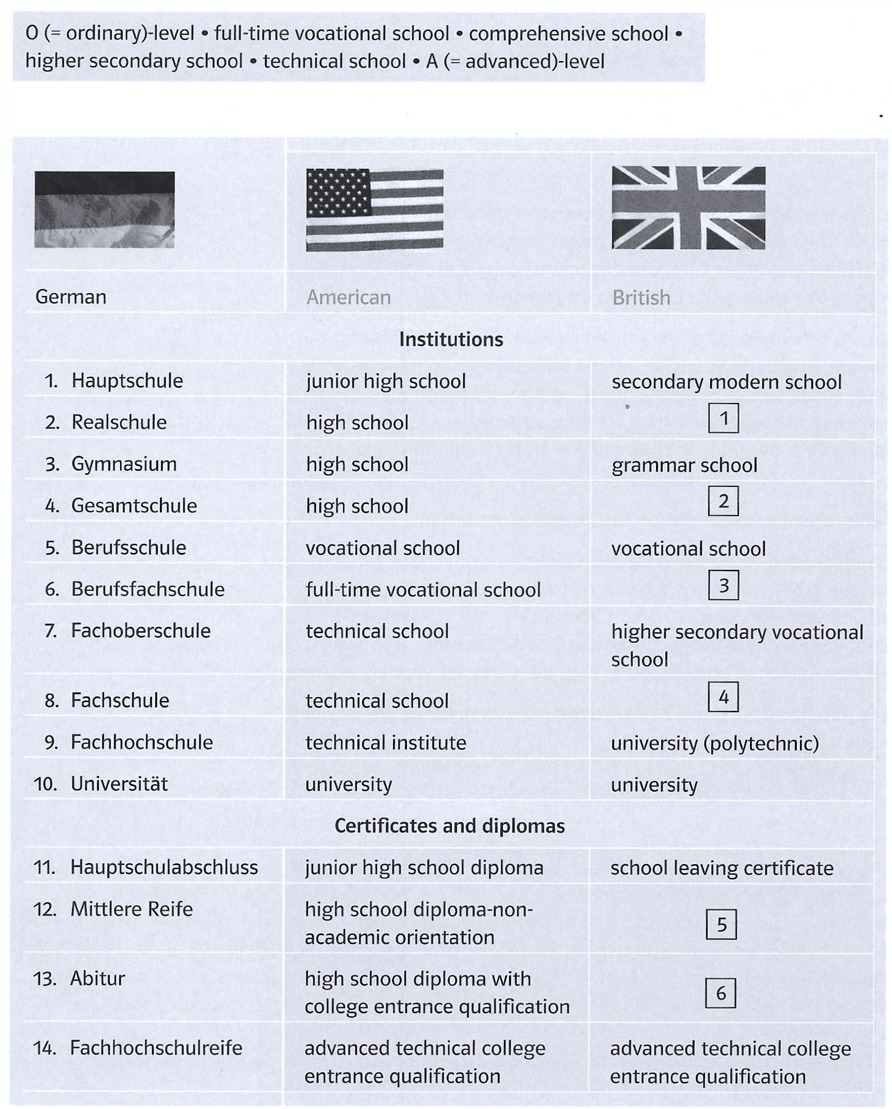

1. **Tips for writing a CV in English**

a) Read the two texts below and make a list of dos and don’ts about writing a CV in English.

b) Name things which are different from Germany.

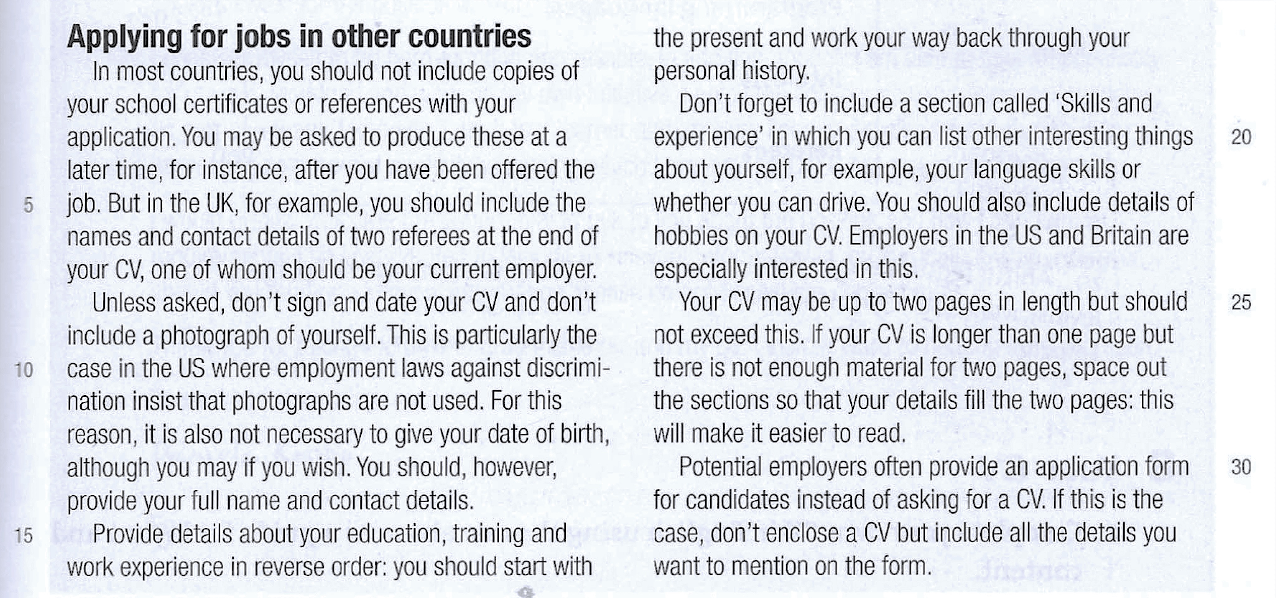

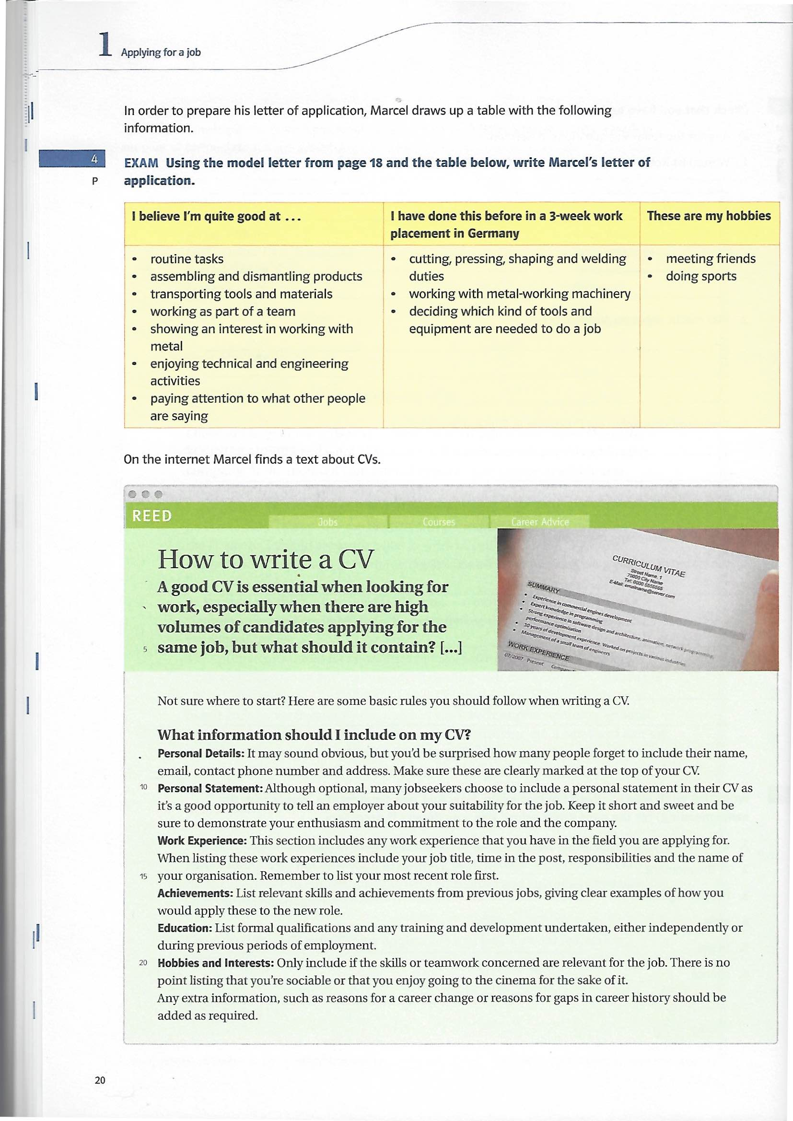

1. **Thinking about your skills**

You think about the skills you have learned during your apprenticeship.

1. What do you enjoy most about your apprenticeship? What skills are you learning (at the company and at the vocational school)? How do you learn and develop these skills?

*E.g. diagnose and repair computer problems, update the databank without any help, scanning and capturing data, installing software, etc.*

1. What other skills have you gained e.g. through your hobbies, internships, a year abroad, volunteering? Make a list and give examples how you gained these skills.

*E.g. team work 🡪 playing football in a team, intercultural skills 🡪 experience abroad*

1. Now talk about your skills in a small group. Compare your ideas and make a list of skills which are important in your area of work.
2. **Writing a Europass CV**
3. Read the CV instructions and look at the sample Europass Curriculum Vitae (moodle). Look up unfamiliar vocabulary and note down questions, if there are any.
4. Prepare your own CV in the Europass format in English and upload it on moodle.

**Instructions:**

* Use the following link: <https://europa.eu/europass/en/create-europass-cv>
* Switch the language of the page to English, your CV must also be in English.
* You don’t necessarily need to create a Europass profile. You will be able to export your CV as a PDF, but you won’t be able to edit it and unsaved changes (in case of technical problems) will be lost.
* Your personal information (email, phone number, address etc.) can be fictitious, your skills and competences must be true.
* Your CV must contain at least these sections: **work experience** (e.g. current training company, internships, jobs etc.), **education and training** (vocational school, high school, …), **language skills, communication and interpersonal skills** (e.g. team work, presentation skills, …), **digital skills, hobbies and interests.**
* You can add additional competences that you may have acquired, for example by leading a youth group, doing volunteer work or through other activities.
* Provide in your information **in reverse chronological order (new information first).**